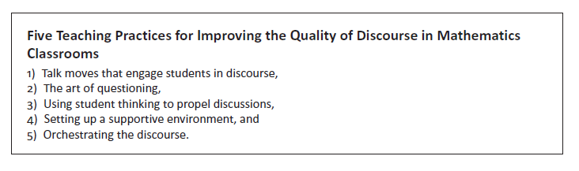

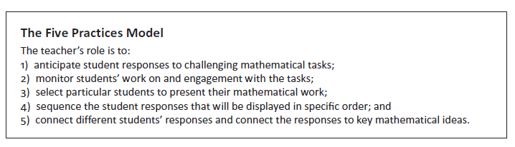

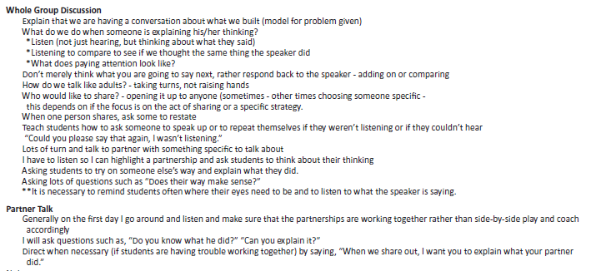

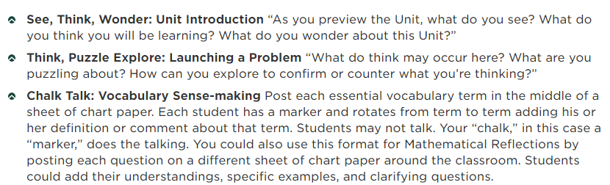

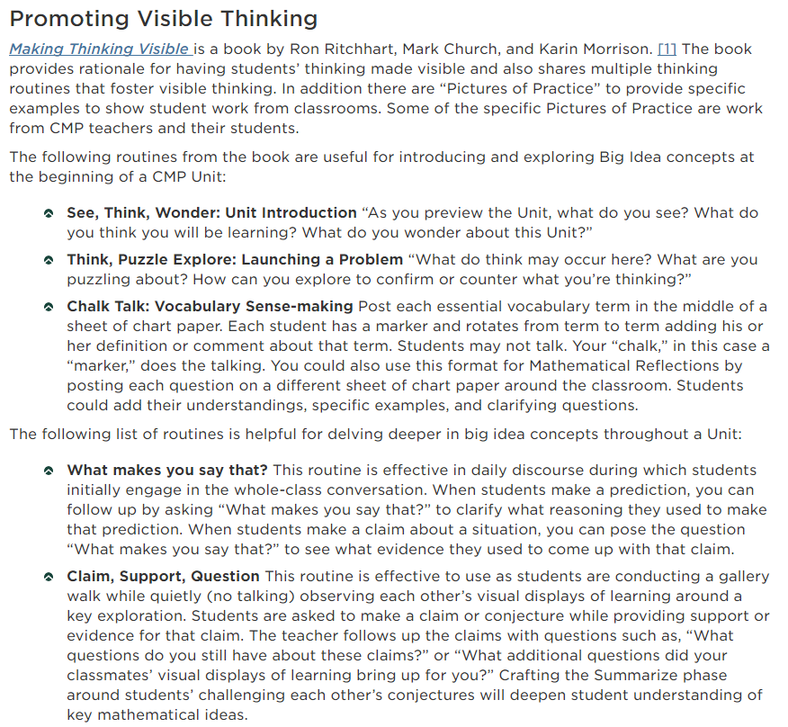

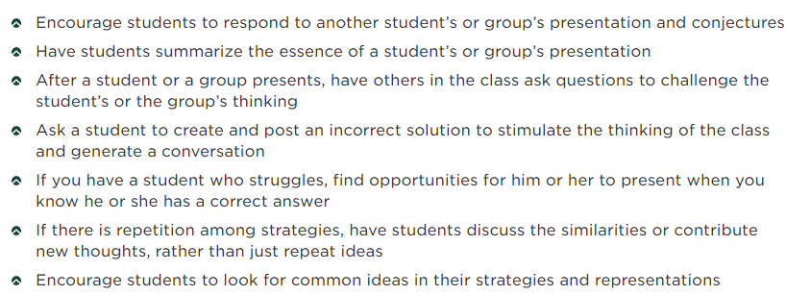

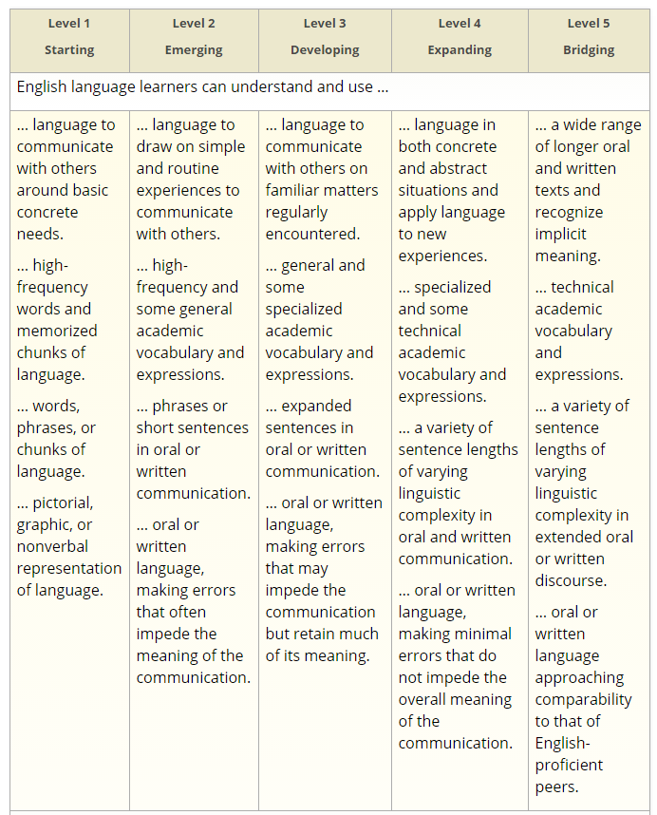

EVEN THOUGH THIS IS ESL, IT REALLY MAKES YOU THINK WHERE ARE STUDENTS WHEN THEY ANSWER OR ASK A QUESTION.

NO PENCIL!